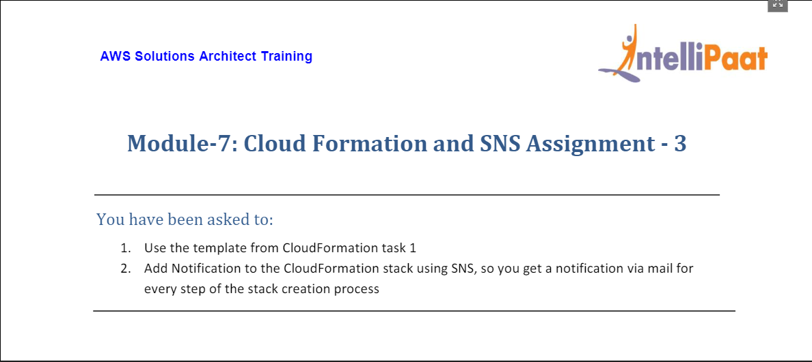

1. For this assignment, head to the CloudFormation service from AWS Console Management (Home).

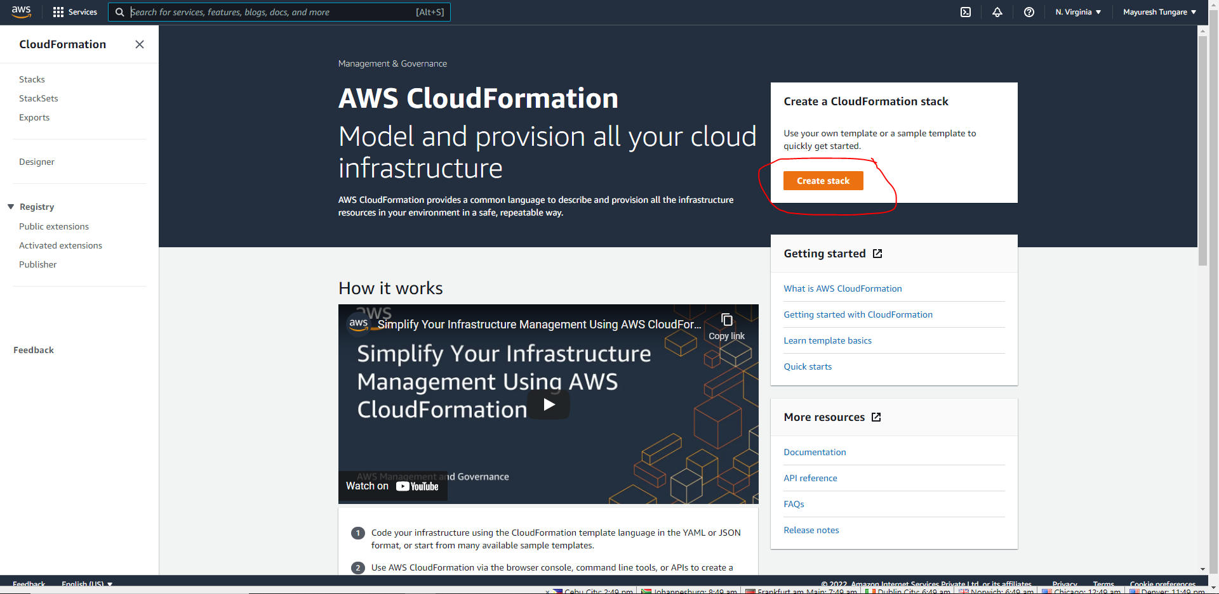

1. In the meanwhile, create a YAML template for bucket creation and SNS topic creation and subscription. The YAML code can be seen below:

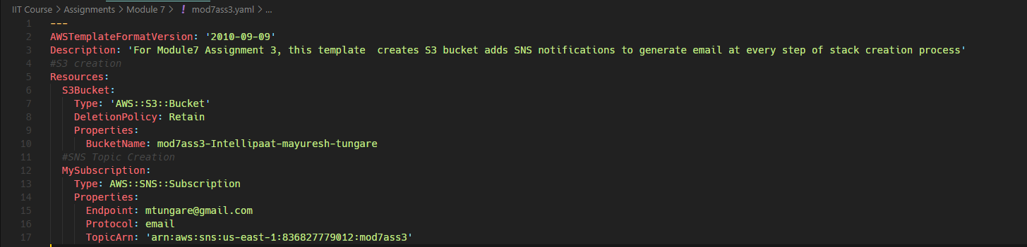

1. From Create Stack in Step1, you can upload the YAML template on the next screen as shown below:

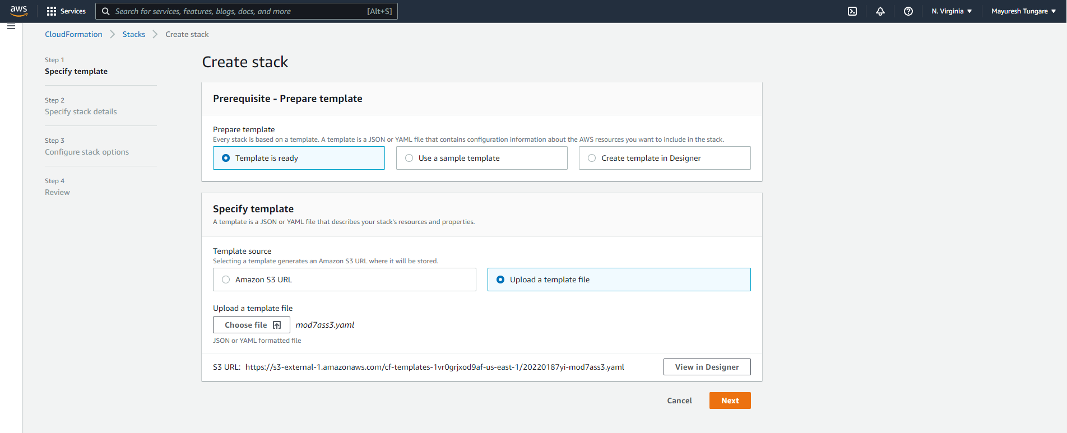

1. Click on next and on the final screen click on ‘Create Stack’:

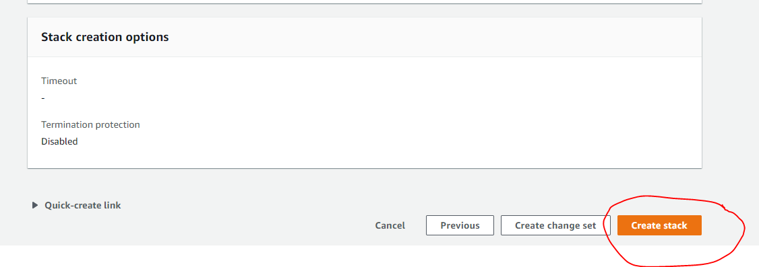

1. This should create the stack as below:

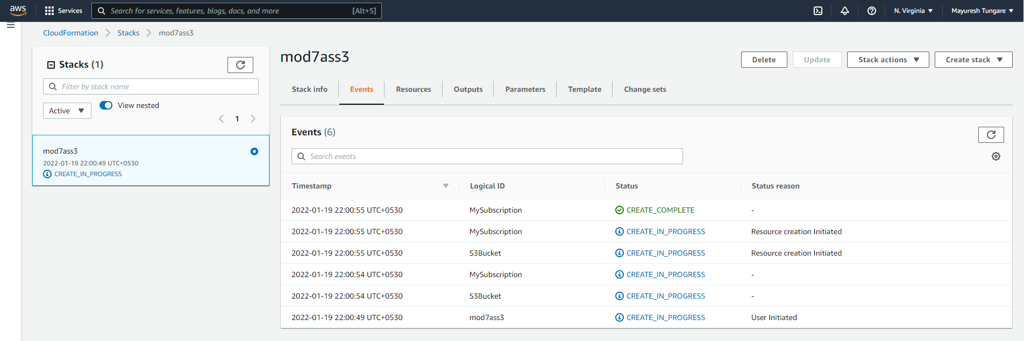

1. Thus this assignment is now complete.